Hybrid CNN Transformer Network
Graphs

Rahul C, Prashanth V, Raghvendra G.

13-Dec-2025

Advanced Deep Learning Techniques Project Report

CVT-VIT-CNN Comparison Data

1.1 CIFAR-10

CIFAR-10 | CNN | ViT | CvT
Epoch | 100 | 100 | 100
Training Duration | 0h 54m 27s | 2h 34m 51s  (9291s) | 1h 42m 50s  (6170s)
GFLOPs | 2.26 | 32.5 | 8.0
Parameters | 6.19M | 95M | 20M
Train Accuracy @1 | 58.9% | 34.3% | 70.3%
Test Accuracy @1 | 42.3% | 89.1% | 90.3%
Train Accuracy @5 | 95.16% | 84.77% | 93.75%
Test Accuracy @5 | 94.78% | 99.55% | 99.71%

1.2 Tiny-ImageNet

ImageNet | CNN | ViT | CvT
Epochs | 60 | 60 | 60
Training Duration | 02h 09m 47s (7782.27s) | 06h 10m 05s (22205.93s) | 03h 26m 20s (12380.14s)
GFLOPs | 2.26 | 32.5 | 8.16
Parameters | 6.19M | 95M | 20M
Train Accuracy @1 | 19.1% | 16.8% | 37.1%
Test Accuracy @1 | 10.2% | 64.51% | 63.1%
Train Accuracy @5 | 44.1% | 39.45% | 66.4%
Test Accuracy @5 | 26.0% | 86.77% | 85.9%

1.3 CIFAR-10 Plots

1.3.1 CvT Accuracies
Accuracy@1 Accuracy@5
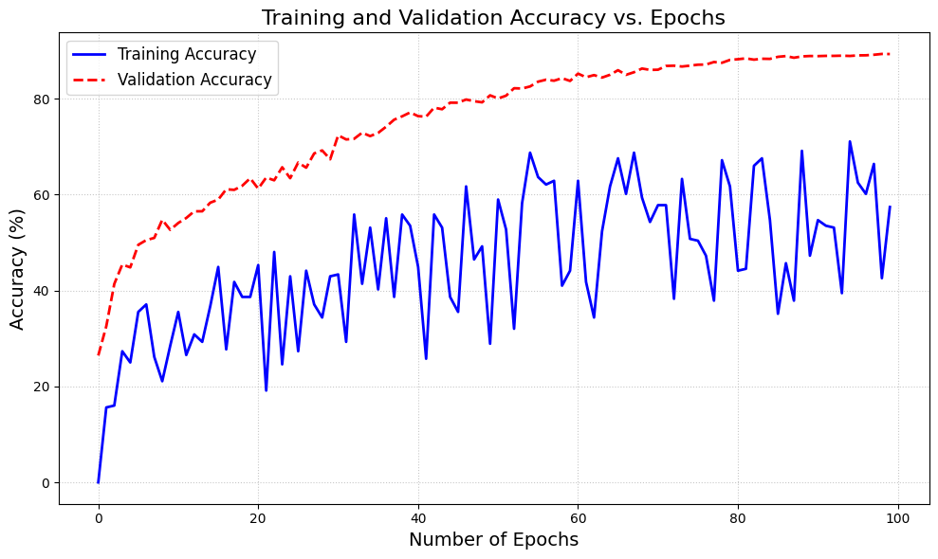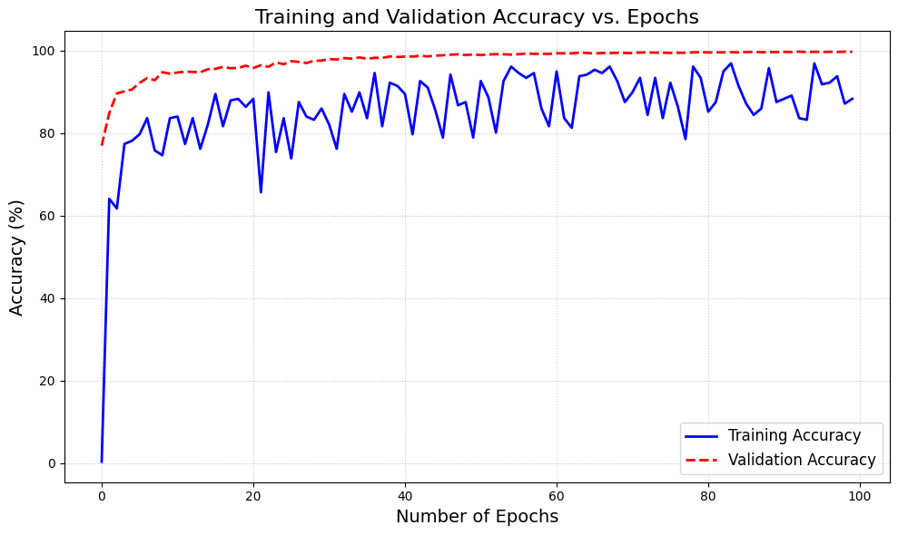

1.3.2 ViT Accuracies
Accuracy@1 Accuracy@5

1.3.3 CNN Accuracies
Accuracy@1 Accuracy@5
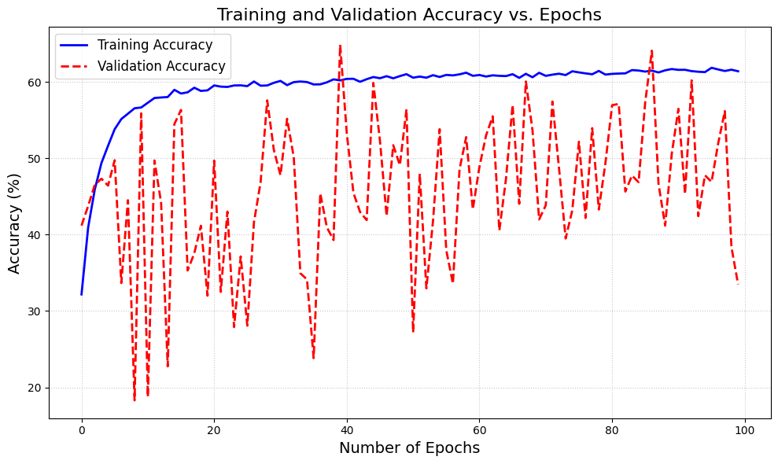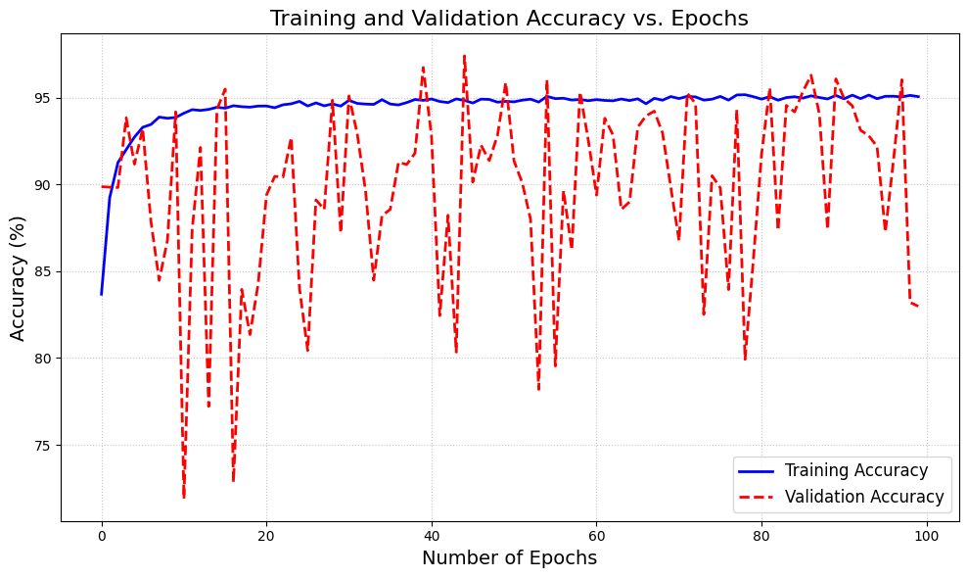

1.4 Tiny-ImageNet Plots

1.4.1 CvT Accuracies

Accuracy@1 Accuracy@5
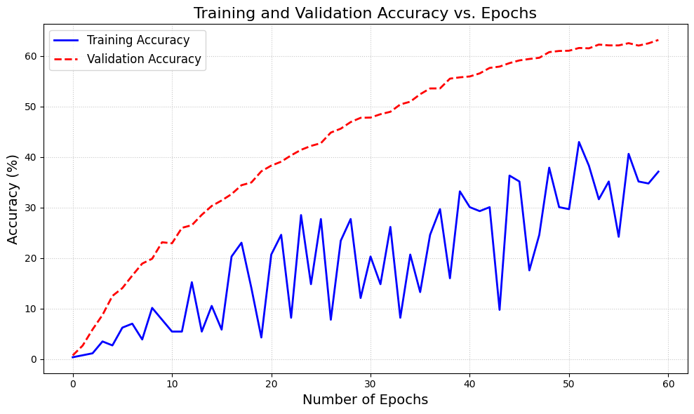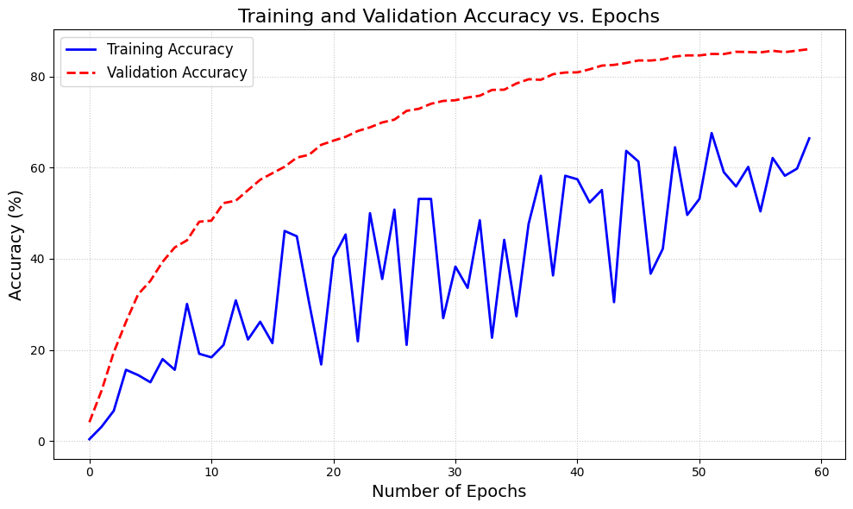

1.4.2 ViT Accuracies

Accuracy@1 Accuracy@5
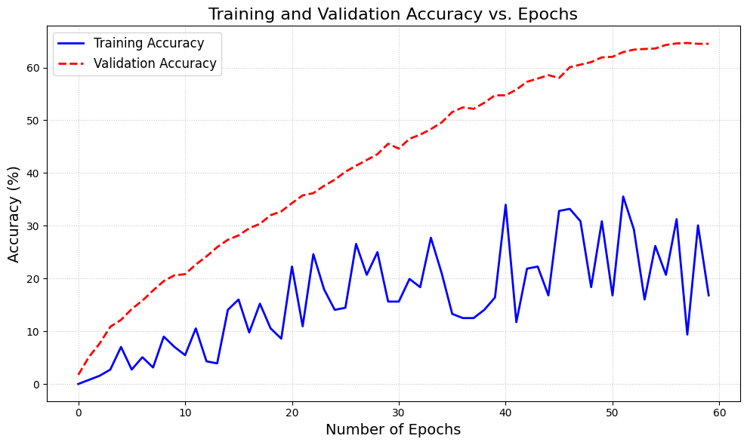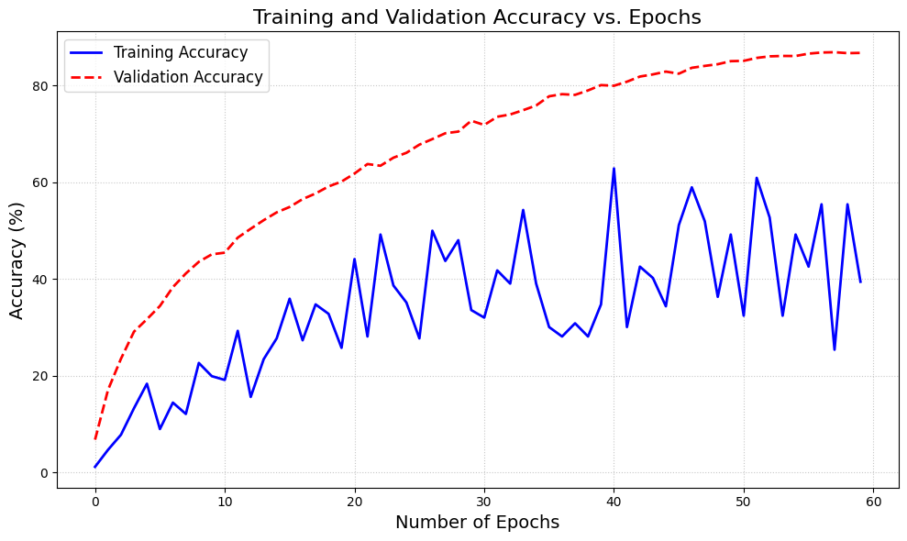

1.4.3 CNN Accuracies

Accuracy@1 Accuracy@5
